**Design and Development of a Web-based Government Housing Management System**

**A Project Report**

Submitted to the Department of Computer Science and Engineering, Jahangirnagar University in partial fulfillment of the requirements for the degree of Master of Science in Computer Science under PMSCS program.

**Submitted by:**

Md. Rezaul Karim

Roll: CSE202103115

Batch: 27th

**Supervised by:**

Professor Dr. Md. Ezharul Islam



**Department of Computer Science and Engineering  
Jahangirnagar University, Savar, Dhaka-1342**

**Bangladesh**

**November , 2022**

**Approval of Acceptance**

This project report written by Md Rezaul Karim (ID: CSE202103115) entitled Web-based Government Housing Management Systemis submitted to the PMSCS Program, Department of Computer Science and Engineering, Jahangirnagar University in partial fulfillment of the requirements for the degree of Master of Science in Computer Science. The project is done under the supervision of Professor Dr. Md. Ezharul Islam, Department of Computer Science and Engineering, Jahangirnagar University.

We have examined this report and recommend its acceptance.

…………………………………………………………………………..

Dr. Md. Ezharul Islam

Supervisor and Professor

Department of Computer Science and Engineering

Jahangirnagar University

Savar, Dhaka-1342, Bangladesh

………………………………………………………………………………

[Sarnali Basak](https://juniv.edu/teachers/sarnali.cse)

Second Examiner Associate Professor

Department of Computer Science and Engineering

Jahangirnagar University

Savar, Dhaka-1342, Bangladesh

Accepted by:

………………………………………………………………………………

###### Professor [Dr. Md. Humayun Kabir](https://juniv.edu/teachers/hkabir)

Coordinator

PMSCS Program 2022-2023

Department of Computer Science and Engineering

Jahangirnagar University

# Savar, Dhaka-1342, Bangladesh

# Declaration

I, hereby, declare that the work presented in this report is the outcome of the investigation performed by me under the supervision of Professor Dr. Md. Ezharul Islam, Department of Computer Science and Engineering, Jahangirnagar University. The work was spread over one final semester course: Research Project, in accordance with the course curriculum of the department for the Professional Masters of Science in Computer Science.

…………………………………..........................

Md. Rezaul Karim

Roll Number: CSE202103115

Registration No: 2859

Batch : 27th

# Acknowledgment

I cannot express enough thanks to my supervisor **Dr. Md. Ezharul Islam** Department of Computer Science and Engineering, Jahangirnagar University for his continued support and encouragement.

I would like to express my sincere gratitude to Professor. **Dr. Md. Humayun Kabir**, Coordinator, PMSCS Program 2020-2021, Department of Computer Science and Engineering, for his kind help in completing my project and honorable faculty members and my department of staffs.

Finally, to my caring, loving, and supportive wife, Naznin Parvin : my deepest gratitude. Your encouragement when the times got rough are much appreciated and duly noted. It was a great comfort and relief to know that you were willing to provide management of our household activities while I completed my work. My heartfelt thanks.

# Abstract

The main objective of this application is to help the Government Employee to manage the operations and activities of apartments. This is a simple user interface developed using MVC Technology . It helps the user to keep track of all apartment booking status, allocation status , maintenance related information of the different apartments of a particular Industries. It helps the Government Housing Management System to reduce the cost of maintaining these records. There will be a big database which stores all the data related to these various apartments, their booking and allocated related information etc. It helps to keep track of all the payments done by employee towards maintenance etc. This project will ease the user to manage huge data of different Employee who own apartments from the same builder. It will record the date of application ,booking and PRL Information. For the maintenance part of the interface it shall have the data of all the maintenance charges paid by the Employee, whether its done quarterly or annually. It also records the mode of payment. It will also hold all the details such as the apartment related

.

**Table of Contents**

**Chapter 1 Introduction Page No**

* 1. Motivation 8
  2. Objectives 8
  3. Problem Definition 8
  4. Research Methodology 8
  5. Outline 8

**Chapter 2 Background and Related Works**

2.1 Introduction 9

2.2 Background and History 9

2.3 Related Work and Gap Analyze 9

2.4 Gap Comparison Table 9-13

**Chapter 3 System Design**

3.1 PHP Analysis and Design 14

3.2 Requirements Analysis 15

3.3 Use Case Diagram 16

3.4 Model Code and Design 17

3.5 ERD and Database Design 18

3.6 Table Structure 19-21

**Chapter 4 Implementation and Results**

4.1 GUI Design and Test Case 22-30

4.1 Code for php 21-34

4.3 Hardware Requirement for PHP & MysqlDB 34

4.4 Snapshots for Run Project 35

4.5 Testing 35

**Chapter 5 Conclusion and Future Works**

5.1 Conclusion 36

5.2 Future Works 36

**References** 37

**List of Figures**

**Page No.**

Figure 2.1: Ministry of Housing and Public work Web Site landing Page 10

Figure 2.2: Police Officers Housing Management System Web Site Landing Page 11

Figure 2.3: National Board of Revenue Web Site Landing Page 12

Figure 3.1: MVC format of PHP for this Project 14

Figure 3.2: Use Case Diagram 16

Figure 3.3: High level of ERD 17

Figure 3.4: Model List 18

Figure 3.5: Database table details 18

Figure 3.6: Table Structure 19

Figure 3.8: GUI Design for Home Page 21

Figure 3.9: GUI Design for Login 22

Figure 3.10: GUI Design for Registration 23

Figure 3.11: GUI Design for Application 24

Figure 3.12: GUID Design Application list 24

Figure 3.13: GUI Design Notice for Admin 27

Figure 3.14: GUI Flat Information for Admin 28

Figure 3.15: GUI Design Reports for Admin 30

Figure 4.1: Snapshots for run Project 35

# Chapter 1

**Introduction**

* 1. **Motivation**

The Design and Development of a Web-based Government Housing Management Systemof the proposed system is not a system that replaces the old system, but the system proposed is the addition or development of the old system is manual to computerized. The proposed design procedure is made in order to minimize flaws, weaknesses, and overcome the problems encountered. The design procedure is expected to provide a solution to a new alternative that can maximize the delivery of information booking at the Housing or Apartment

* 1. **Objectives**

The main objective of this application is to help the Government Employee to manage the operations and activities of apartments. It helps the user to keep track of all apartment booking status, allocation status , maintenance related information of the different apartments of a particular Industries. It helps the Government Housing Management System to reduce the cost of maintaining these records. There will be a big database which stores all the data related to these various apartments, their booking and allocated related information etc. It helps to keep track of all the payments done by employee towards maintenance etc. This project will ease the user to manage huge data of different Employee who own apartments from the same builder. It will record the date of application ,booking and PRL Information. For the maintenance part of the interface it shall have the data of all the maintenance charges paid by the Employee, whether its done quarterly or annually. It also records the mode of payment. It will also hold all the details such as the apartment related

* 1. **Problem Definition**

It is a very difficult task to collect the information of all the employee and create a database. Moreover Government Housing Management System Web application is the only way to collect information from any where in the world

* 1. **Research Methodology**

I took an initiative to development a web system. Through which a solution to all problem can be solved. In creation this system, I will use HTML5, CSS,2.1, Bootstrap3 , JavaScript, PHP 7.4 framework Codeigniter (MVC) ,MySQL

* 1. **Outline**

This Government Housing Management System is developed in such a way where any Government Housing can be able to Maintenance their organization easily. Simple and easy admin panel to manage all Process. This system can store huge data as an archive. Can build report if need in future. Most popular and Common language are used to develop this web system. Every user can see basic information but restricted to access permission

**Chapter 2**

**Background and Related Works**

**2.1 Introduction**

The interface helps the user to login through the system and add the details regarding the apartment. There are two type of users applicant users and Admin users.

The Admin users will login the system and the interface takes an input the flat related all Information . Also The admin user will approved and cancel all application information and also generate the related reports. The Applicant user is normal users that can be application the free flat and get notification And approval related all reports

**2.2 Background and History**

A Government Housing Management System is a software application for the operation of allocated , booking and maintenance , especially in the Government Sector. Housing Management System are sometimes referred to as public sector, and often people limit their services to being used in housing. However, a Housing Management System can be used in various organizations such as real estate, manufacturing , logistics , intellectual property , government and commercial or residential rental properties.

The best way to think of a Housing Management System is as a centralized online system that manages day-to-day operations such as organizing, scheduling, allocated and booking and much more. They are the ultimate organizers for businesses that are looking to automate their workforce and maximize efficiency.

.

**2.3 Related Work and Gap Analyze**

Housing Sector Some of the dominant strategies for housing and service provision for the Bangladesh include slum upgrading and site and service schemes. However, the efficiency of these strategies has been limited by ambivalent government attitude to irregular settlement. These strategies have failed because of a reliance on inappropriate building by-laws and infrastructural standards and modern designs, construction technology and conventional building materials that all make housing unaffordable to the poor, even after subsidies. Thus, government initiatives in assisting house owners in management have proven to be pathetically slow with many of the houses provided being economically and socially irrelevant, this further prompting the rise of informal

[**Ministry of Housing and Public Work**](https://mohpw.gov.bd/)

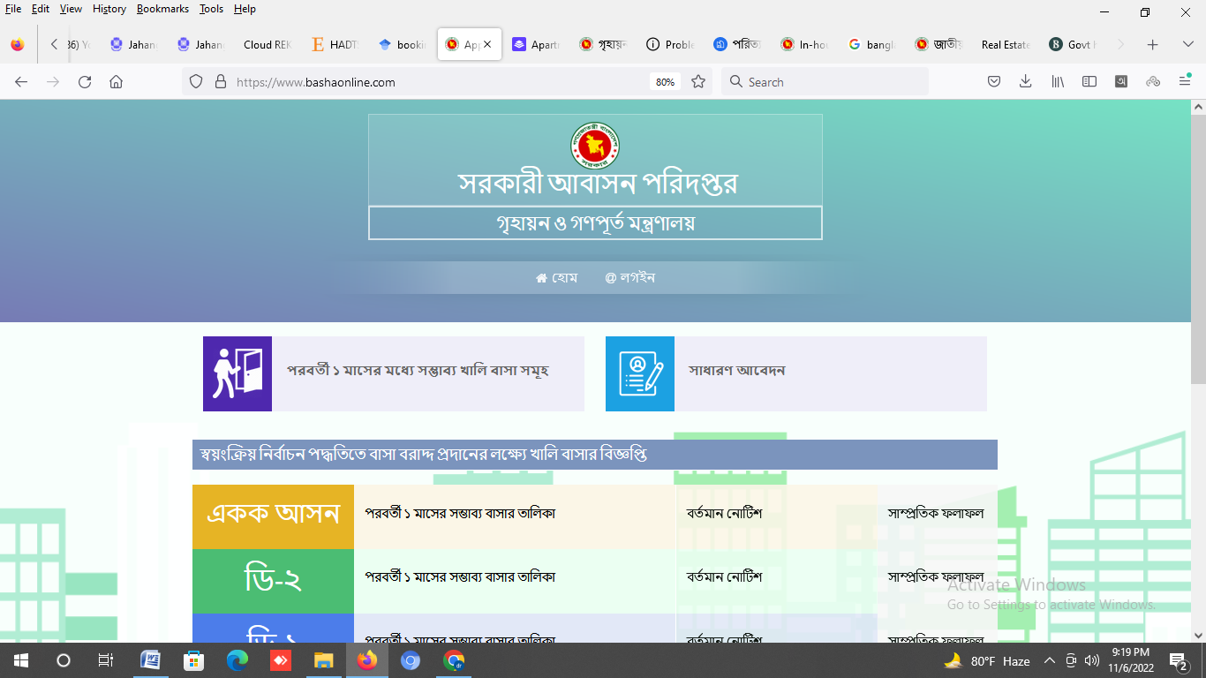

Figure 2.1 : Ministry of Housing and Public Work

|  |  |  |
| --- | --- | --- |
| SL | Feature Name | Description |
| 1 | Home | This is Landing Page |
| 2 | Notice | All message, Organization & Management. |
| 3 | Registration | Applicant Registration Form |
| 4 | Login | Login admin/normal users |
| 5 | Application for Booking | Apply for flat booking |
| 6 | Applicant user dashboard | Normal User related all reports display |
| 7 | Previous History | All previous history display |
| 8 | Admin panel login | Login admin panel |
| 9 | Flat information | Insert data all flat information |
| 10 | All Application list | Can show all Application list |
| 11 | All Approval list | Can Approved all Application list |
| 12 | Management Related all Report | Display all management related report |

Figure 2.2 : Feature Description Details

**Police Officers Housing Management System**

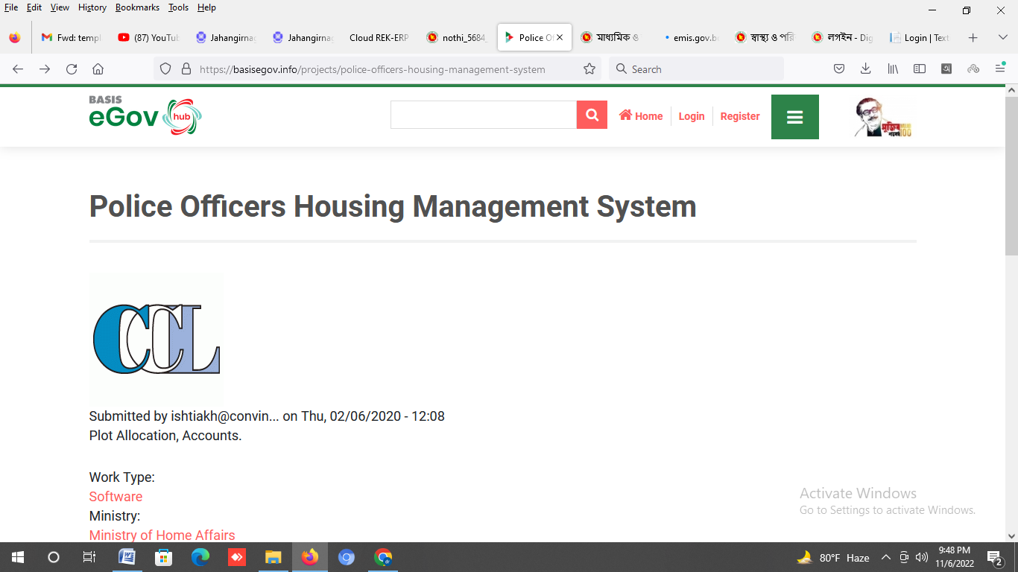

Figure 2.2 : Police Officers Housing Management System

|  |  |  |
| --- | --- | --- |
| SL | Feature Name | Description |
| 1 | Home | This is Landing Page |
| 2 | Notice | All message, Organization & Management. |
| 3 | Registration | Applicant Registration Form |
| 4 | Login | Login admin/normal users |
| 5 | Application for Booking | Apply for flat booking |
| 6 | Applicant user dashboard | Normal User related all reports display |
| 7 | Previous History | All previous history display |
| 8 | Admin panel login | Login admin panel |
| 9 | Flat information | Insert data all flat information |
| 10 | All Application list | Can show all Application list |
| 11 | All Approval list | Can Approved all Application list |
| 12 | Management Related all Report | Display all management related report |

**National Board of Revenue Web Site**

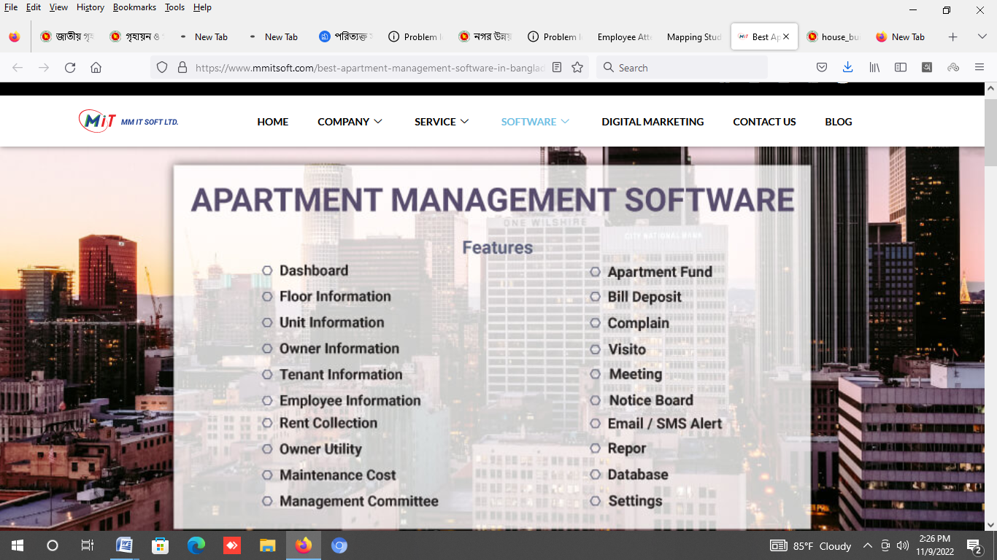

Figure 2.3 : National Board of Revenue Apartment System

|  |  |  |
| --- | --- | --- |
| SL | Feature Name | Description |
| 1 | Dashboard | This is Landing Page |
| 2 | Floor Information | All Floor Information |
| 3 | Unit Information | All Unit Information under Floor |
| 4 | Owner Information | Owner Information |
| 5 | Tenant Information | Tenant Information |
| 6 | Employee Information | All Employee information of Group/Department |
| 7 | Rent Collection | Rent Collection for every Unit |
| 8 | Maintenance Cost | Maintenance Cost for every Category |
| 9 | Apartment Fund | Apartment Fund Collection |
| 10 | Meeting | Weekly / Monthly Meeting Information |
| 11 | Notice Board |  |
| 12 | Reports | Display all management related report |
| 13 | Setting |  |

**Comparison Table with others System**

|  |  |  |  |  |
| --- | --- | --- | --- | --- |
| SL | Feature Name | Description | Others | PMSCS |
| 1 | Home | This is Landing Page | Yes | Yes |
| 2 | Notice | All message, Organization & Management. | No | Yes |
| 3 | Registration | Applicant Registration Form | Yes | Yes |
| 4 | Login | Login admin/normal users | Yes | Yes |
| 5 | Application for Booking | Apply for flat booking | Yes | Yes |
| 6 | Applicant user dashboard | Normal User related all reports display | No | Yes |
| 7 | Previous History | All previous history display | No | Yes |
| 8 | Admin panel login | Login admin panel | Yes | Yes |
| 9 | Flat information | Insert data all flat information | Yes | Yes |
| 10 | All Application list | Can show all Application list | Yess | Yes |
| 11 | All Approval list | Can Approved all Application list | Yes | Yes |
| 12 | Management Related all Report | Display all management related report | No | Yes |

**Chapter 3**

**System Design**

**3.1 PHP Analysis and Design**

A High-level PHP web framework is Codigniter that motivates perfunctory development and clean, technical design. Now a days it is the most powerful and Common web framework for web development. I have used PHP5 and Codeigniter Framework(MVC) and GUI for HTML5 to develop Government Housing Management Information System.

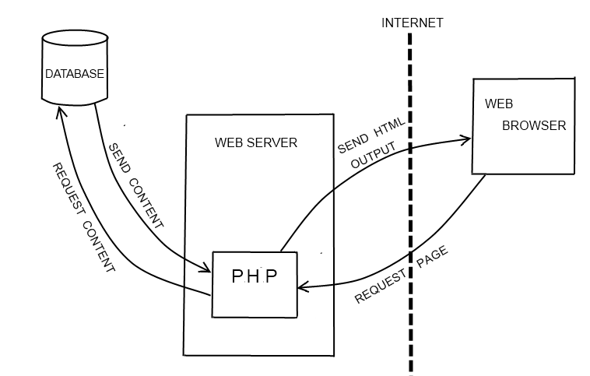

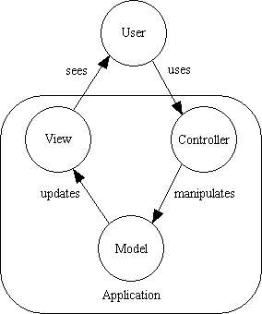

Figure 3.1: MVC format of PHP

**3.2 Requirements Analysis**

Government Housing Management functional requirement are following:-

1. Landing/Home

* Home
* Notice Board
* Login
* Registration

1. Registration

* Registration Form
* User name
* Password

1. Login

* Simple two step authenticated login system
* Applicant authentication
* Admin authentication

1. Administrator Dashboard

* Flat Type Information
* Flat Information
* All Application related work
* Admin can full control of the web site content
* Admin can add/delete/update user access
* Related All Reports

1. Applicant Dashboard

* Home page
* Notice
* Registration
* All history
* Message
* Related All Reports

# 3.3 USE CASE

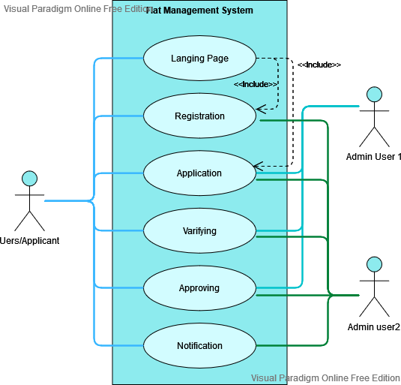

Figure 3.2 : use case

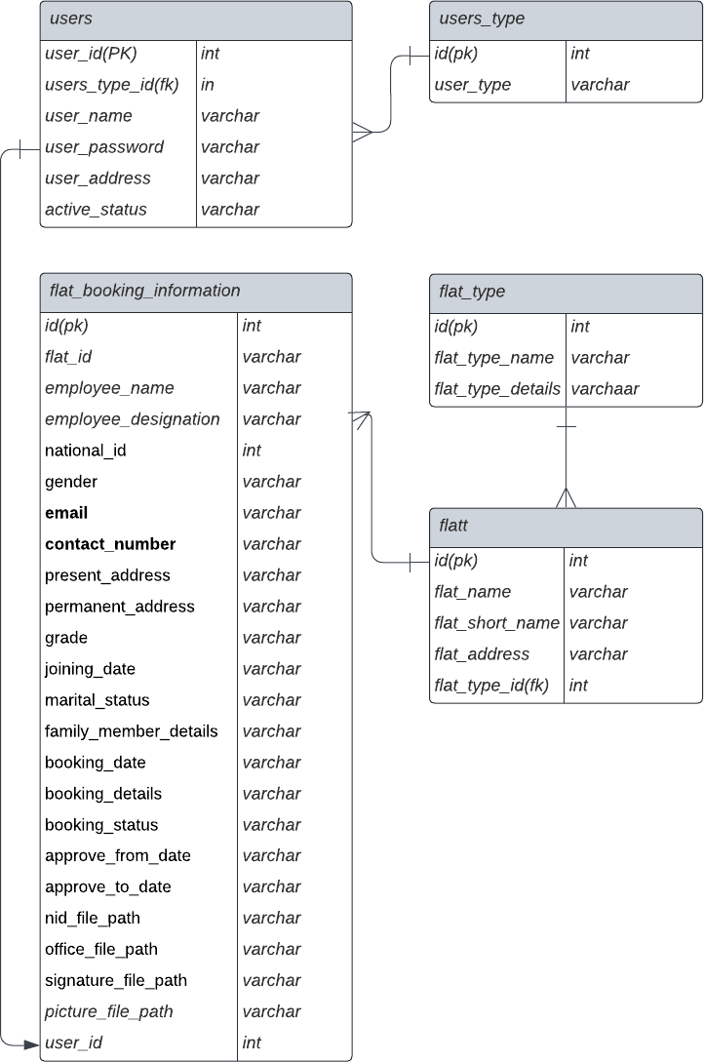 **3.4 Entity Relation Diagram (ERD)**

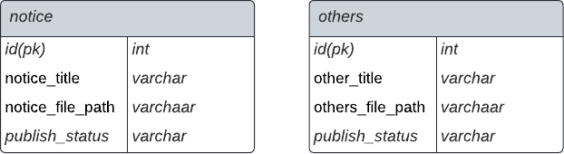

Figure 3.3 : Entity Relation Diagram (ERD)

**3.5 Model Code and Design**

|  |  |  |
| --- | --- | --- |
| Index Model | Flat Model | Others Model |
| 1. Basic setup 2. Slider 3. Notice 4. Message 5. Registration 6. Login 7. Flat list 8. Others | 1. Flat type 2. Flat Type list 3. Flat Information 4. Flat Information List 5. Flat application list 6. Flat Allocated list 7. Flat Cancel List | 1. Reports 2. Others |

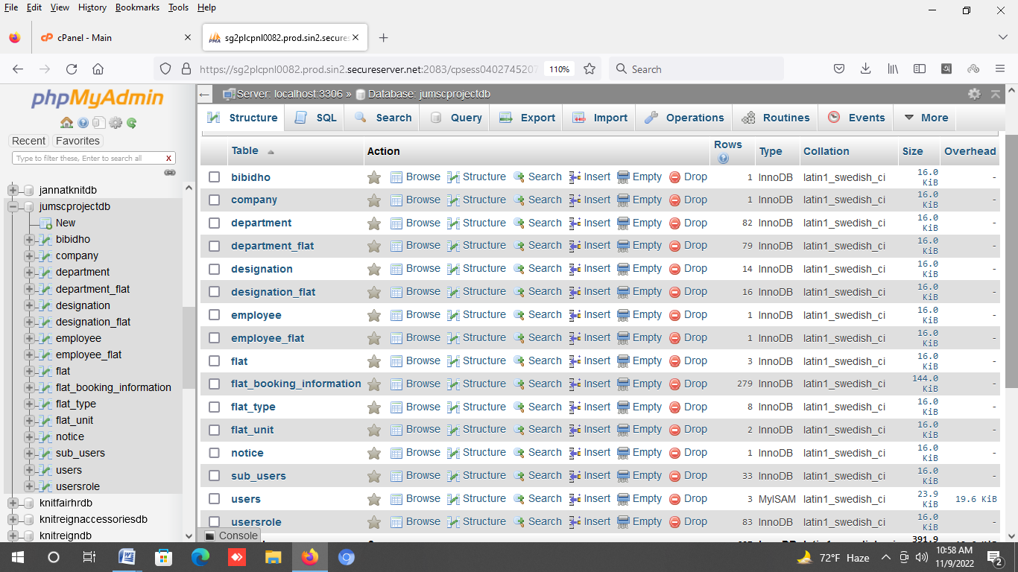

Figure 3.5 : Database

**3.7 Table structure**

**Table Name : Users**

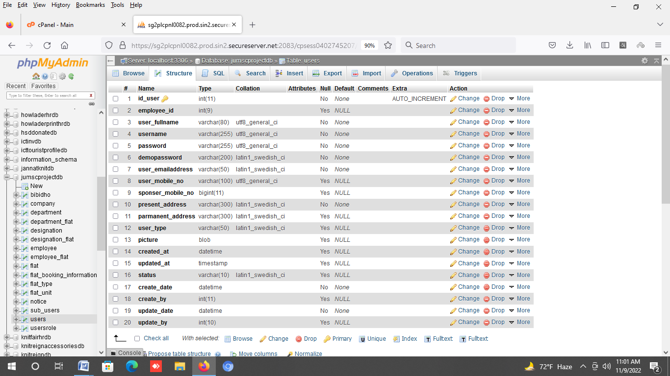

Table 3.6 : Users

**Table Name : flat_type**

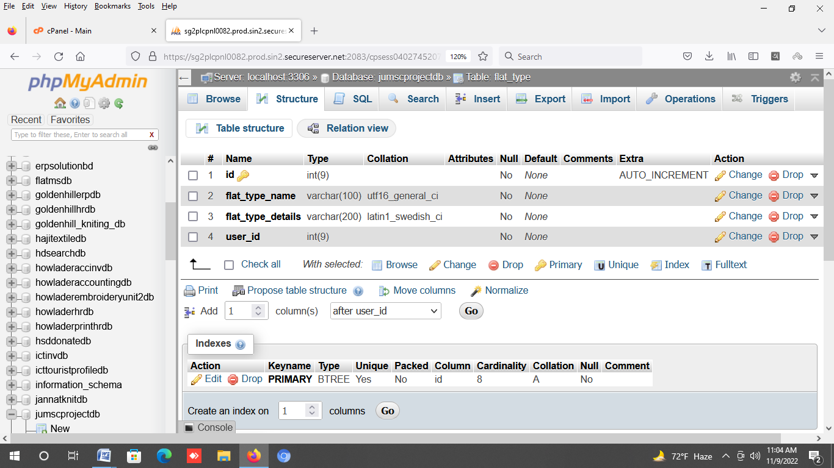

Table 3.7 : flat_type

**Table Name : flat**

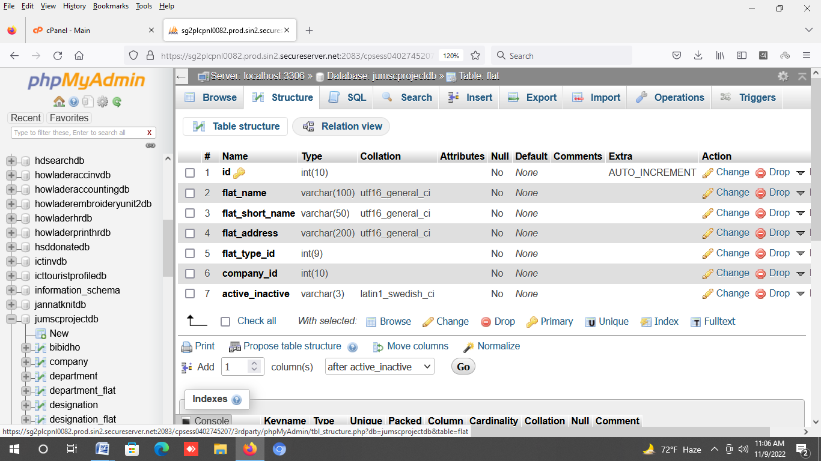

Table 3.8: flat

**Table Name : flat_booking**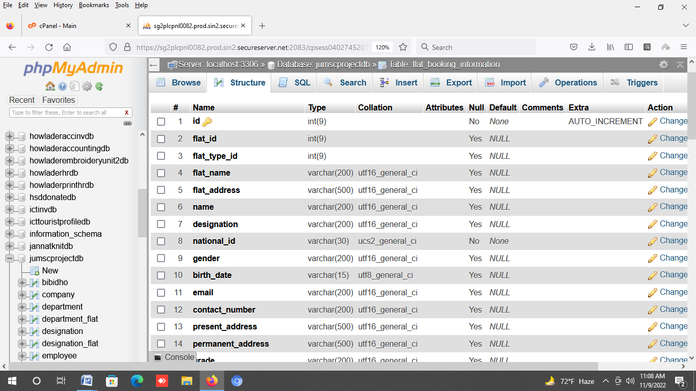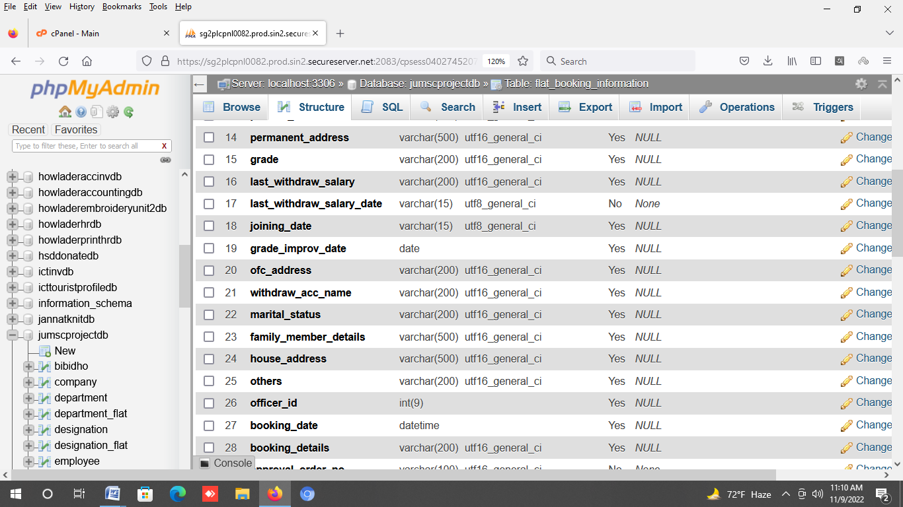

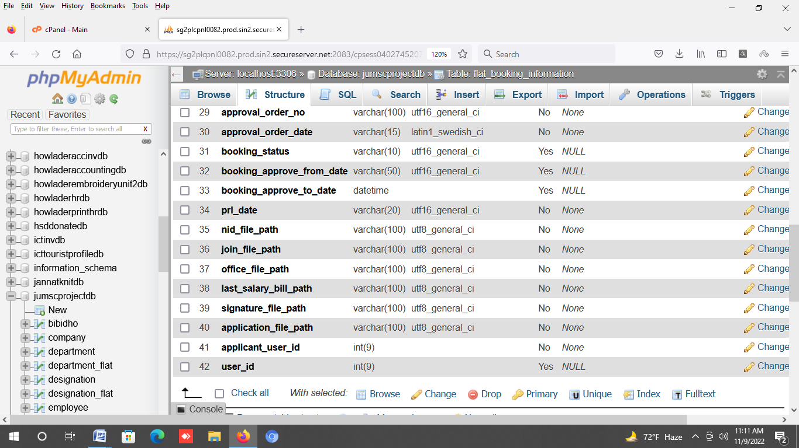

Table 3.8: flat_booking

**Table Name : bibidho**

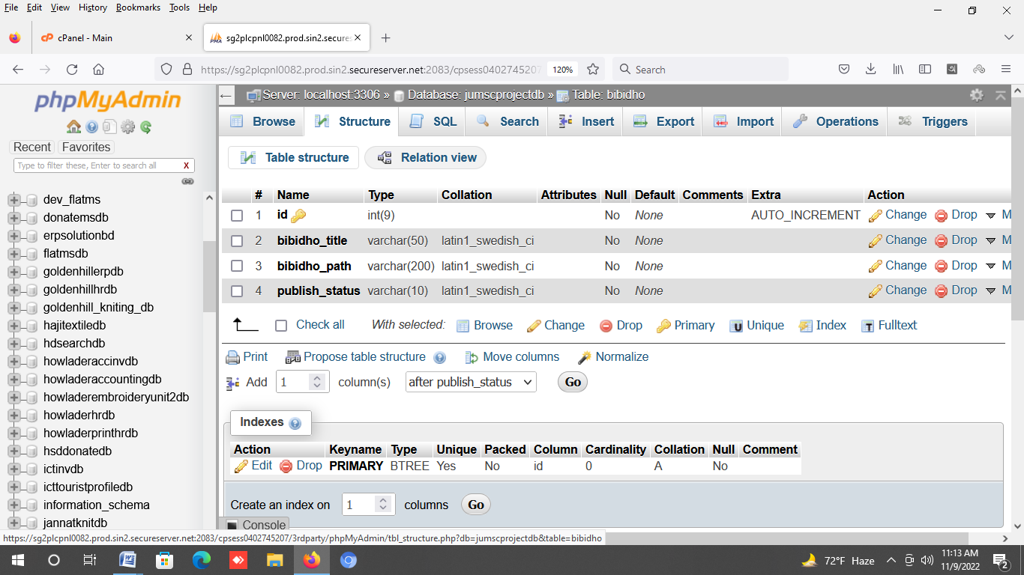

Table 3.8: bibidho

**Table Name : Notice**

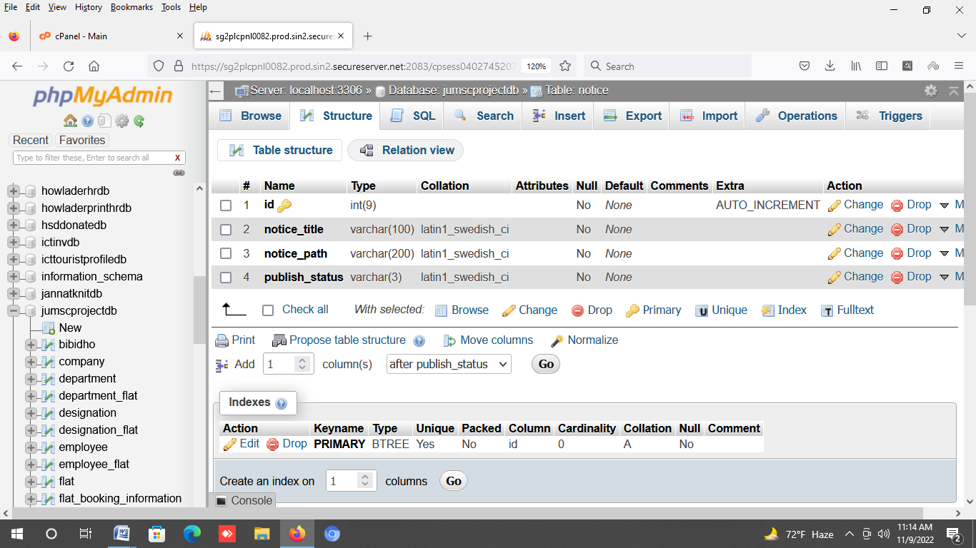

Table 3.8: Notice

**Table Name : Company**

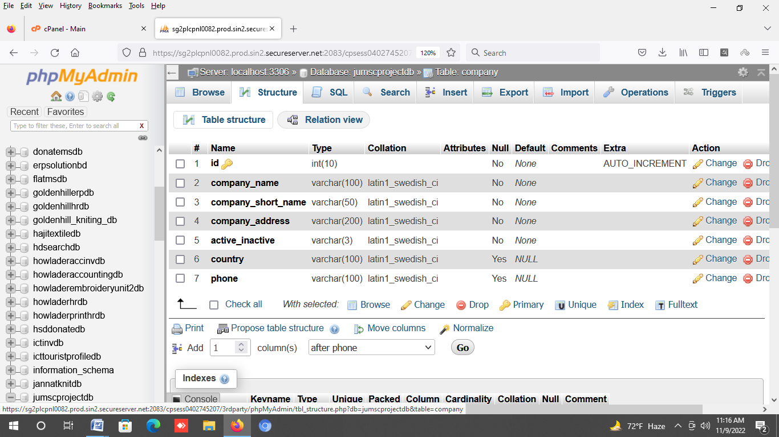Table 3.10 : employee

**Chapter 4**

**Implementation and Results**

**4.1 GUI Design and Test Case**

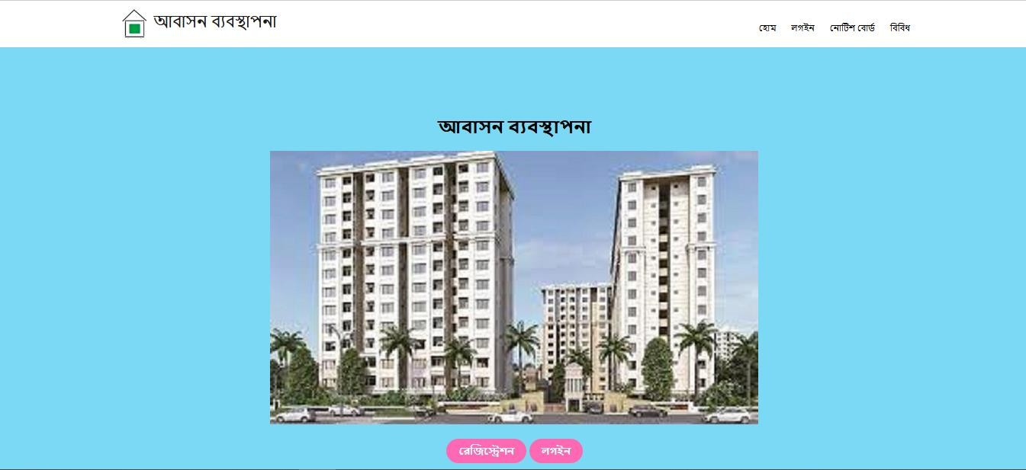**Landing Page :**

Figure 3.8 : landing page

Test Case : Landing page/Home

|  |  |  |  |  |
| --- | --- | --- | --- | --- |
| ID | Description | Step | Data | Expected Result |
| 1 | Landing page/Home | Enter Registration |  | User can display  Registration Page |
| 2 | Landing page/Home | Enter Login |  | User can display  Registration Page |
| 3. | Landing page/Home | Enter Notice |  | User can display Notice Page |

**Login Page :**

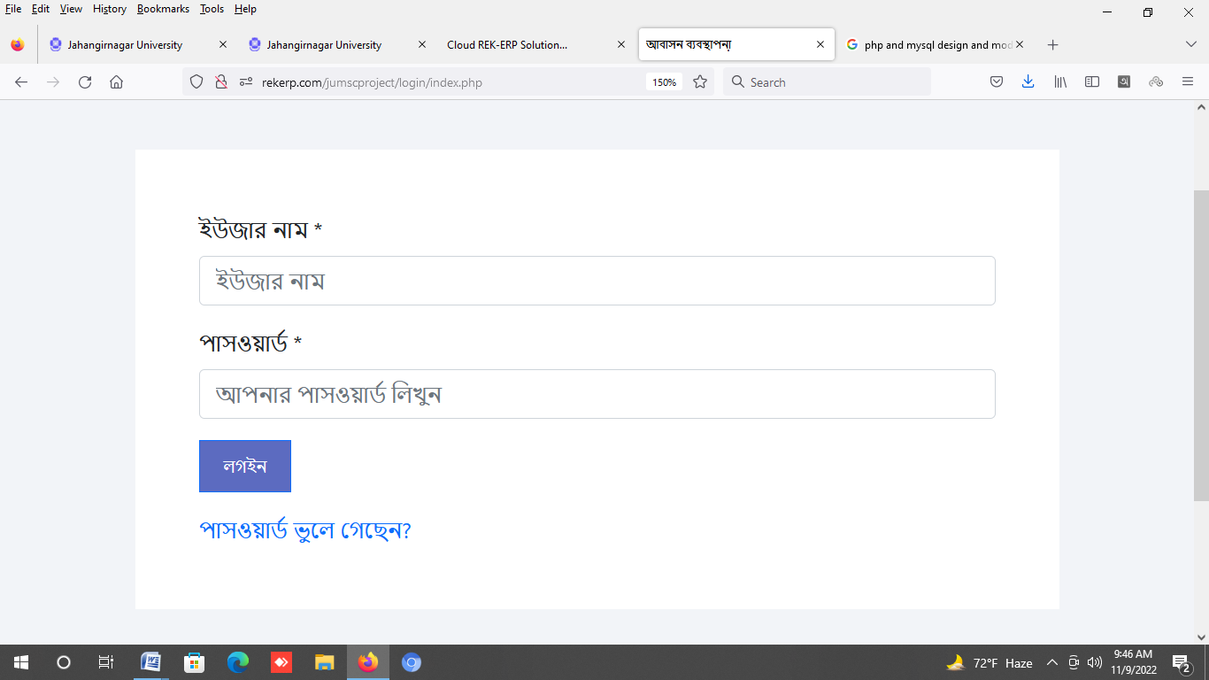

Figure 3.9 : login page

**Test Case : Login**

|  |  |  |  |  |
| --- | --- | --- | --- | --- |
| ID | Description | Step | Data | Expected Result |
| 1 | Loging page for application | Enter user name  Enter password (max 10 character) | User name:reza Password : 123 | User should login into Dashboard |
| 2 | Loging page for admin | Enter user name Enter password  (max 10 character) | User name:admin  Password : 123 | User can display Admin Dashboard Page |
| 3. | login page | Password reset | Enter password reset | User can display Password Reset |

**Registration Page :**

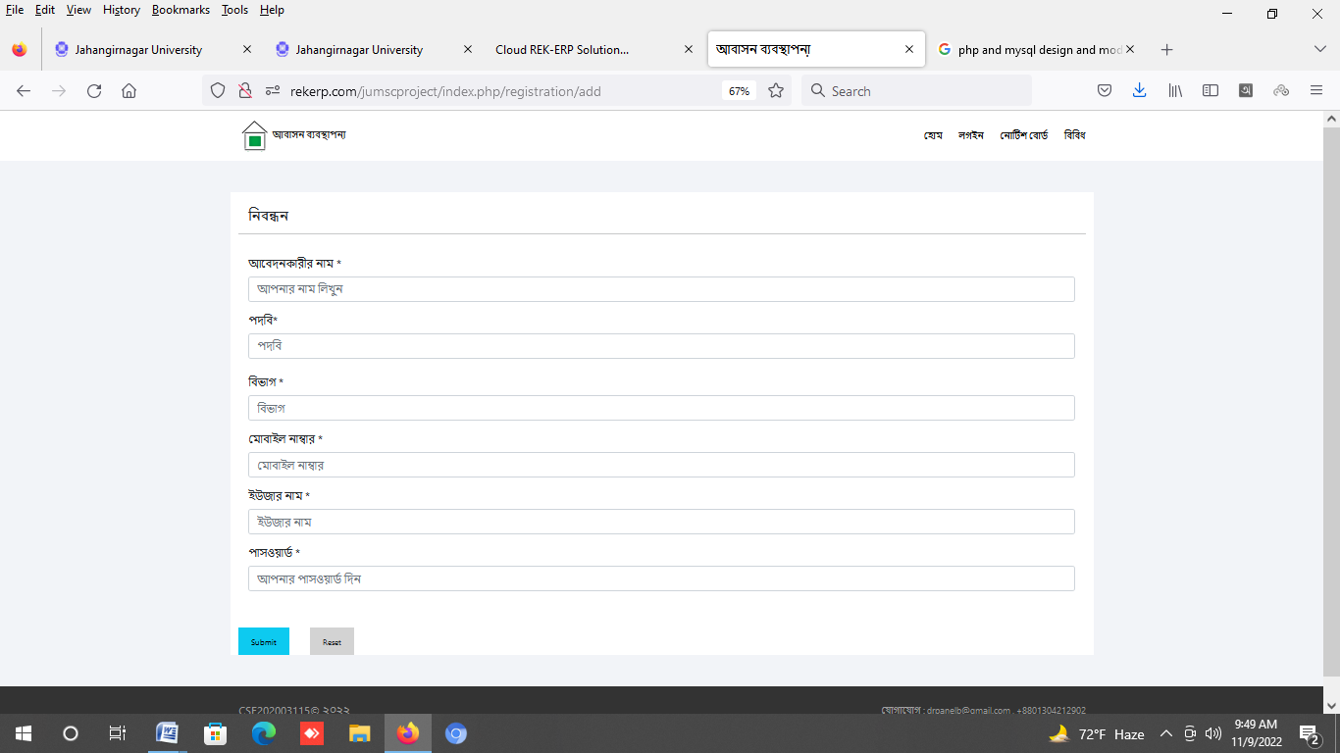

Figure 3.10 : Registration page

**Test Case : Registration**

|  |  |  |  |  |
| --- | --- | --- | --- | --- |
| ID | Description | Step | Data | Expected Result |
| 1 | Application | Enter Applicant Name | Mix 100Character Required | Ok |
| 2 | Designation | Enter Designation Name | Mix 100 Character Required | Ok |
| 3. | Department | Enter Department Name | Mix 100 Character Required | Ok |
| 4 | Mobile No | Enter Mobile No | Mix 50 Character Required | Ok |
| 5 | User name | Enter User Name | Mix 10 Character Required | Ok |
| 6 | Submit | Enter Submit | User Registration Successfully | OK |
| 7 | Reset | Enter Reset | All Field clear | Ok |

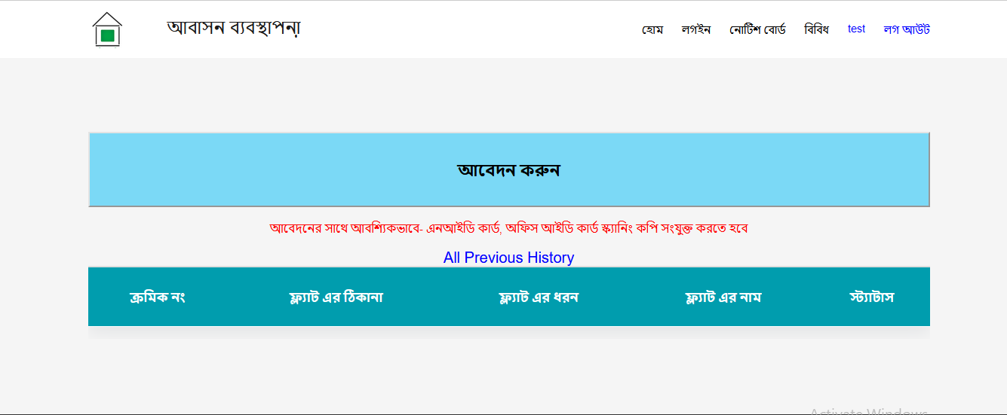**User Dashboard :**

Figure 3.13 : User Dashboard

**Test Case : User Dashboard**

|  |  |  |  |  |
| --- | --- | --- | --- | --- |
| ID | Description | Step | Data | Expected Result |
| 1 | Application | Enter Application |  | Application Details Page Display |
| 2 | Previews All Record |  |  | Previews All Record Show |

**Application flat list :**

Figure 3.12 : Application flat list page 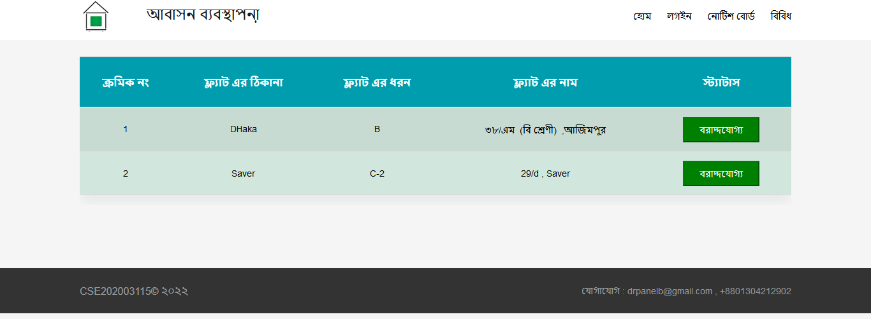

**Test Case : Application flat list**

|  |  |  |  |  |
| --- | --- | --- | --- | --- |
| ID | Description | Step | Data | Expected Result |
| 1 | Flat Available | Flat Available |  | Application Details Page Display |
| 2 | Previews All Record |  |  | Previews All Record Show |

**Application Form :**

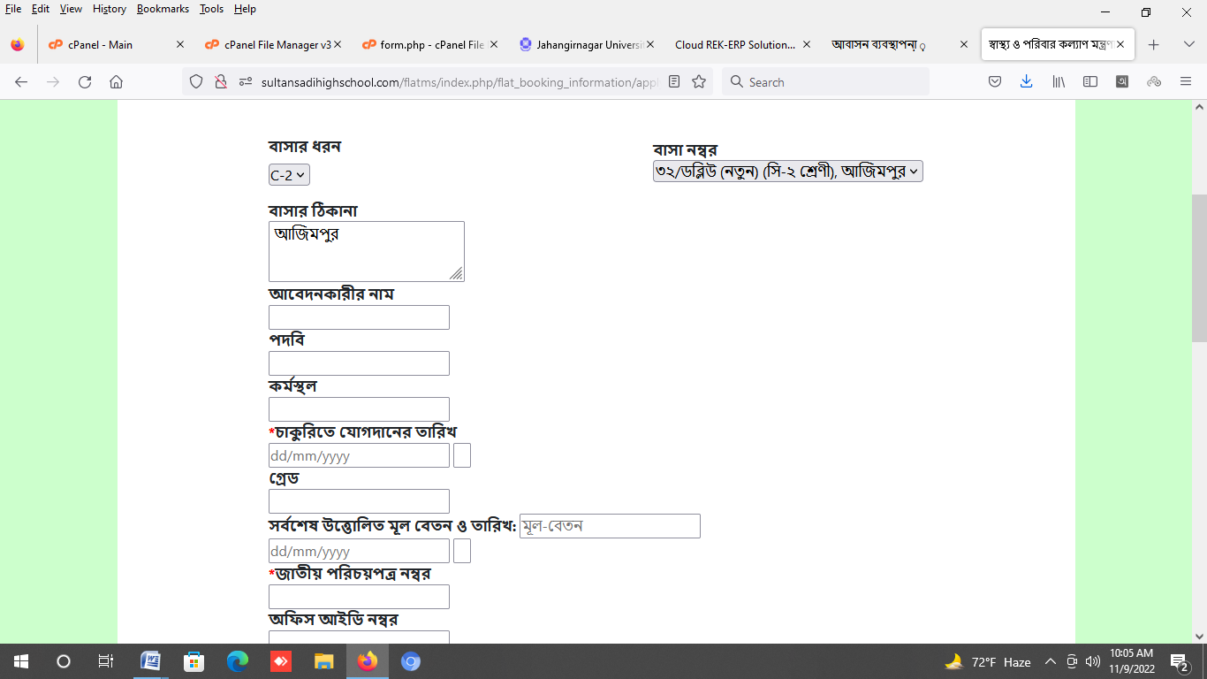

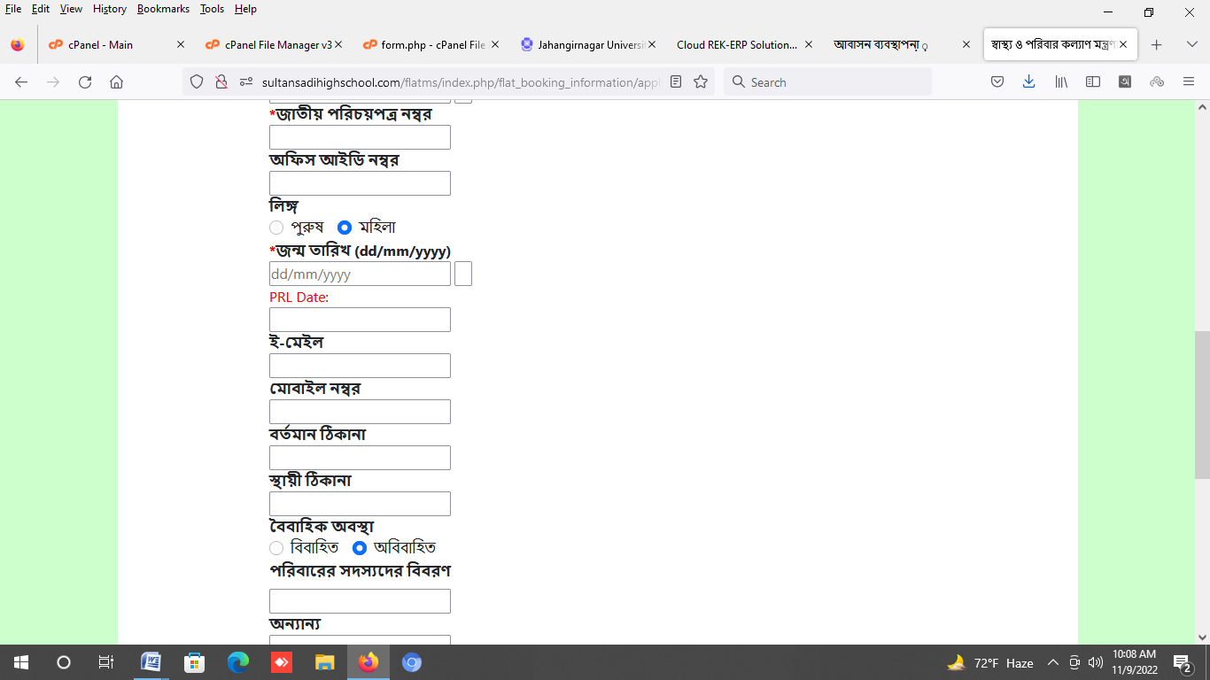

Figure 3.12 : Registration page

**Test Case : Registration page :**

|  |  |  |  |  |
| --- | --- | --- | --- | --- |
| ID | Description | Step | Data | Expected Result |
| 1 | Flat | User Select Flat Name |  | Display Flat  name, flat address |
| 2 | Applicant Name | Enter Application Name | Character field | Ok |
|  |  |  |  |  |

|  |  |  |  |  |
| --- | --- | --- | --- | --- |
| 3 | Designation | Enter Designation Name |  |  |
| 4 | Office Address | Enter Office Address |  |  |
| 5 | Joining Date | Enter Joining Date from date clander | dd/mm/yy |  |
| 6 | Grade | Enter the Grade |  |  |
| 7 | National Id | Enter National Id |  |  |
| 8 | Office Id | Enter Office ID |  |  |
| 9 | Gender | Select Gender |  |  |
| 10 | Date of Join | Select join date calendar |  |  |
| 11 | PRL Date | Select PRL date | Dd/mm/yyyy |  |
| 12 | Mobile NO | Enter Mobile No |  |  |
| 13 | Present Address | Enter Present Address |  |  |
| 14 | Permanent Address | Enter Permanent Address |  |  |
| 15 | Marital Status | Select marital Status |  |  |
| 16 | Family Member | Enter Family Member |  |  |
| 17 | Others | Enter Others |  |  |

**Notice Page:**

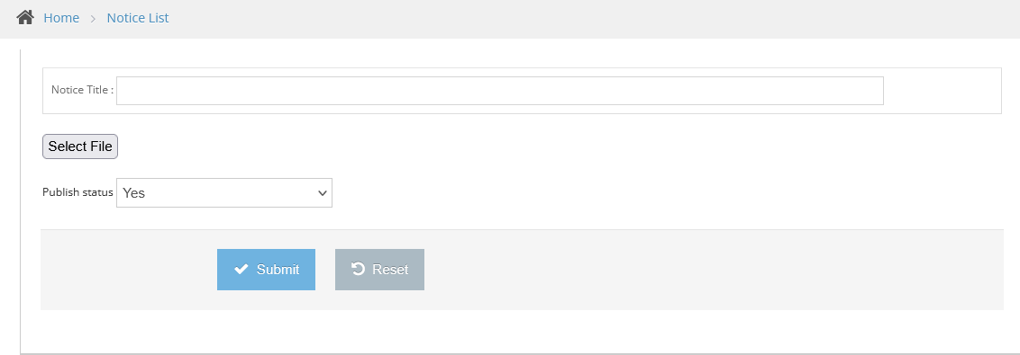

Figure 3.13 : Notice page

**Test Case : Notice Page**

|  |  |  |  |  |
| --- | --- | --- | --- | --- |
| ID | Description | Step | Data | Expected Result |
| 1 | Notice Title | User Enter Notice Title |  | Address |
| 2 | Select File | Select File from Device | Pdf formate | Ok |
| 3 | Public Status | Select Public Status | Active/Inactive |  |
| 4 | Submit | Enter the submit | Insert data in database | Success |

**Flat information :**

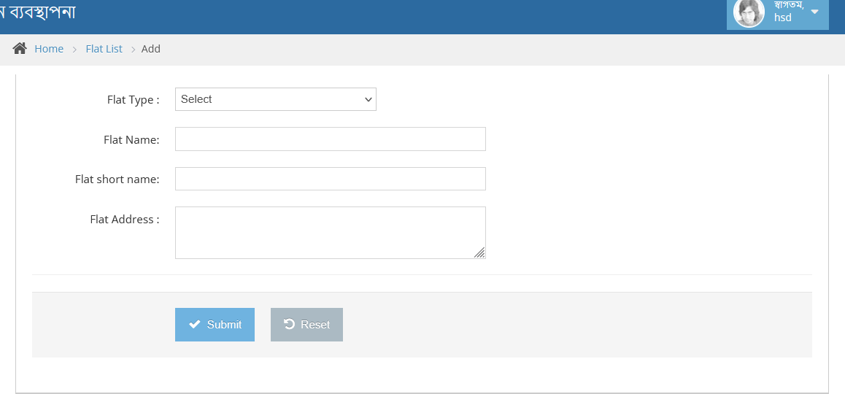

Figure 3.14 : Flat page

**Test Case : Flat**

|  |  |  |  |  |
| --- | --- | --- | --- | --- |
| ID | Description | Step | Data | Expected Result |
| 1 | Flat | User Enter the flat |  |  |
| 2 | Flat Type | Select the Flat type |  |  |
| 4 | Submit | Enter the submit | Insert data in database | Success |

Reports :

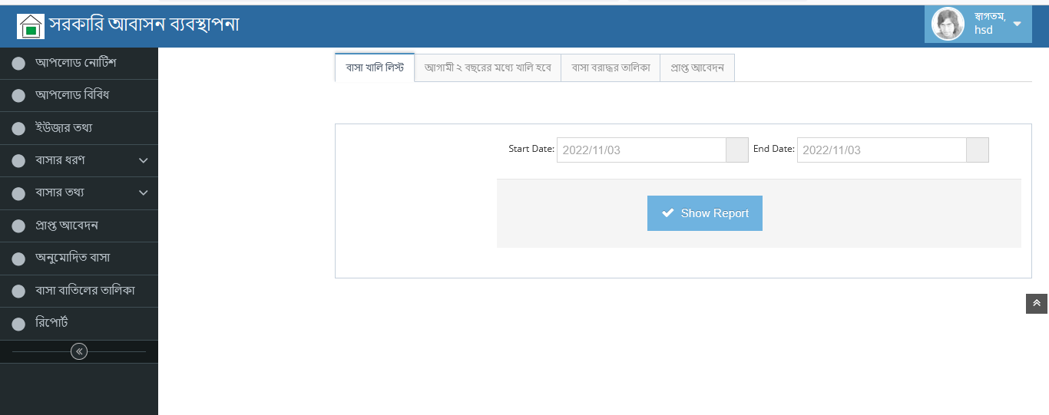

Figure 3.15 : Reports page

Reports : All Flat List

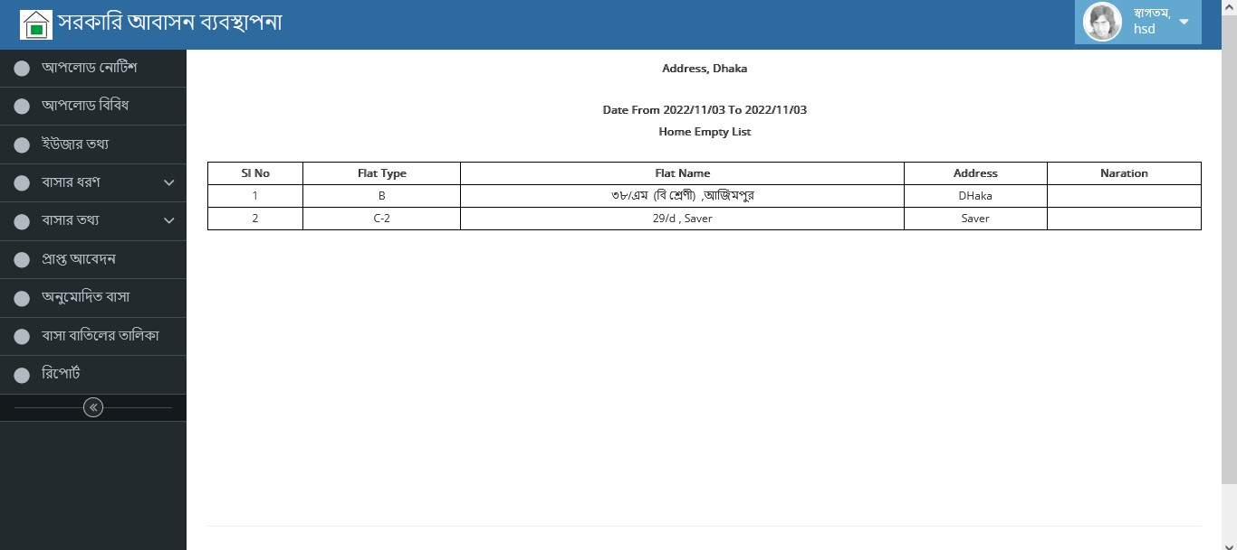

Figure 3.16 : ALL Flat List

**4.2 Code for PHP**

**Controller :**

**<?php**

**class Registration extends CI_Controller {**

**public function __construct()**

**{**

**parent::__construct();**

**}**

**function index()**

**{**

**$this->data['page_title'] = 'Department';**

**$this->data['page'] = 'Department';**

**$this->data['menu'] = 'list';**

**$this->load->view('includes/header', $this->data);**

**$this->load->view('includes/sidebar', $this->data);**

**$this->load->view('department/index', $this->data);**

**$this->load->view('includes/footer', $this->data);**

**}**

**function add()**

**{**

**$this->data['page_title'] = 'Add New Registration';**

**$this->data['page'] = 'Registration';**

**$this->data['menu'] = 'add';**

**$this->data['action'] = 'add';**

**$defaults = array ('department_name'=>'',**

**'department_short_name'=>'',**

**);**

**if($_POST)**

**{**

**$data = array('user_fullname' => $this->input->post('user_fullname'),**

**'username' => $this->input->post('username'),**

**'password' => md5($this->input->post('password')),**

**'user_mobile_no' => $this->input->post('mobileno'),**

**'user_type' => 'aplicant',**

**);**

**$id = $this->m_common->_insert('users',$data);**

**$this->session->set_flashdata('success', "New Users Added Successfully!");**

**redirect('../login/index.php');**

**}**

**Else**

**{**

**$this->data['row'] = $defaults;**

**}**

**$this->load->view('registration/form', $this->data);**

**}**

**}**

**Model :**

**<?php**

**class M_Auth extends CI_Model {**

**function __construct() {**

**parent::__construct();**

**}**

**function check_access()**

**{**

**if ($this->session->userdata('logged_in')) {**

**return true;**

**} else {**

**redirect('login');**

**}**

**}**

**function login()**

**{**

**$this->db->where('username',$this->input->post('username'));**

**$this->db->where('password',md5($this->input->post('password')));**

**$query = $this->db->get('users');**

**$row = $query->row();**

**if(!empty($row))**

**{**

**if($row->user_type=='aplicant')**

**{**

**$data = array(**

**'user_type'=>$row->user_type,**

**);**

**$this->session->set_userdata($data);**

**redirect('http://sultansadihighschool.com/flatms/index.php/');**

**}**

**$data = array('admin_user_id'=>'1',**

**'username'=>$row->username,**

**'logged_in'=>'1',**

**);**

**// Save the user data to a session**

**$this->session->set_userdata($data);**

**return true;**

**}**

**else**

**return false;**

**}**

**}**

**Views :**

**<div id="main-content" class="clearfix">**

**<div id="breadcrumbs">**

**<ul class="breadcrumb">**

**<li>**

**<i class="icon-home"></i>**

**<a href="<?php echo site_url();?>">Home</a>**

**<span class="divider">**

**<i class="icon-angle-right"></i>**

**</span>**

**</li>**

**<li>**

**<a href="<?php echo site_url('flat');?>">Flat List</a>**

**<span class="divider">**

**<i class="icon-angle-right"></i>**

**</span>**

**</li>**

**<li class="active"><?php if($action == 'edit'){?>Edit<?php }else{?>Add<?php }?></li>**

**</ul><!--.breadcrumb-->**

**<!--<div id="nav-search">**

**<form class="form-search">**

**<span class="input-icon">**

**<input type="text" placeholder="Search ..." class="input-small search-query" id="nav-search-input" autocomplete="off" />**

**<i class="icon-search" id="nav-search-icon"></i>**

**</span>**

**</form>**

**</div>--><!--#nav-search-->**

**</div>**

**4.3 Hardware Requirement for php and mysql database**

* Required Memory: 5 GB.
* Required Graphics Card.
* Required CPU: Intel Core i3-2340UE.
* Required File Size: 4 GB.
* Required OS: Windows ,Linux

This are the minimum require hardware information for implementing Government Housing Management System.

**4.4 Snapshots for run project**

URL : http://rekerp.com/jumscproject

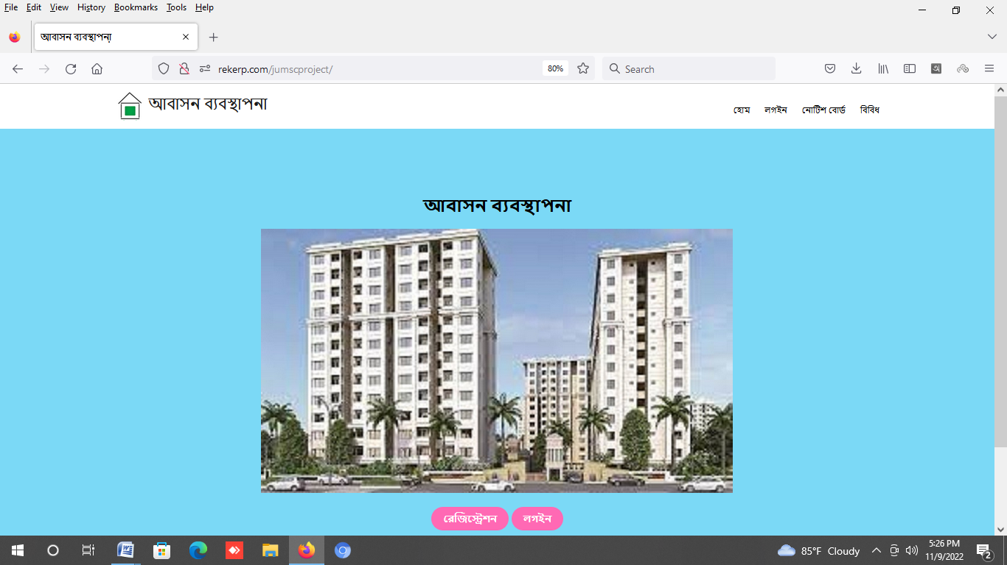

Figure 4.1 : Running landing page

**4.5 Testing**

Testing is the the final phase of software development.

Review software to determine its function and accessibility, evaluating how successful the code is  
• Test specific functions to ensure they meet all expectations and fulfill specifications  
• Create detailed reports of all found bugs and issues, including instructions to replicate them and potential solutions  
• Implement programming fixes on the spot if the problem is simple enough to be tackled immediately  
• Interact with programmers and software developers to relay information about software development and issues  
• Evaluate the aesthetics of software, taking client instruction into consideration and making recommendations to

**Chapter 5**

**Conclusion and Future Works**

**5.1 Conclusion**

The concept of Government Housing management system can be present in many way for this consideration this are for dynamic representation. Any institute can use this system with configuring admin panel. Each and everything are possible to configure inside admin panel.

This are develop by using php(mvc) programming language that are most valuable and high securable among others language.

**5.2 Future Works**

As this system is developed by PHP model Codeigniter framework .So there have easy option to include any model or update. Future I will update technology and develop Mobile apps.

**References[1]**

Ministry of Housing and Public work Web Site landing Page , Accessed : Nov 2, 2022

[Online] Available <https://bashaonline.com> [2]

# Police Officers Housing Management System. , Accessed : Nov 2, 2022

[Online] Available [https:// basisegov.info/projects/police-officers-housing-management-system](https://bashaonline.com) [3] Housing Department Government of West Bengal **,** Accessed : Nov 2, 2022

[Online] Available [https:// wbhousing.gov.in](https://bashaonline.com) [4]

# Amar Basha , Accessed : Nov 2, 2022

[Online] Available https:// www.amarbebsha.com/apartment-management-system/ [5]

# BCOM Govt Housing , Accessed : Nov 2, 2022

[Online] Available http://bcom.gov.bd/demo/residence_application_mod/pages/main/index.php/ [6]

# NOBO IT , Accessed : Nov 2, 2022

[Online] Available https://www.noboit.com/Rent-and-property-management-software.php/ [7]

# Mitsoft Housing Management System , Accessed : Nov 2, 2022

[Online] Available https://www. mmitsoft.com/best-apartment-management-software-in-bangladesh / [8]

# Invetopedia Apartment Management System , Accessed : Nov 2, 2022

[Online] Available https://www. investopedia.com/best-rental-property-management-software-5089988/[9]

# Buildium System , Accessed : Nov 2, 2022

[Online] Available https://www. Buildium.com[10]

# Capita Housing Management software, Accessed : Nov 2, 2022

[Online] Available https://www.capita.com/services/housing-management-software [11]

# BCNPHA Apartment Management system , Accessed : Nov 2, 2022

[Online] Available https://bcnpha.ca/member-program/property-management-software/ [12]

## **Online Rental Property Management Software ,** Accessed : Nov 3, 2022

## [Online] Available https://www.onsitepropertymanager.com/ [13]

# NECSWS Housing Management system , Accessed : Nov 3, 2022

[Online] Available  [https://www.necsws.com/solutions/housing-management-solution/](%20https://www.necsws.com/solutions/housing-management-solution/%20) [14]

# JARA Apartment Management system , Accessed : Nov 4, 2022

[Online] Available https://www.atlassian.com/ [15]

### Housing Software - Advanced, Accessed : Nov 4, 2022

### [Online] Available [https://www.oneadvanced.com](%20https://www.oneadvanced.com%20) [16]

# Housing Management Software student Affairs , Accessed : Nov 4, 2022

[Online] Available

[https://uwm.edu]( https://uwm.edu )  [17]

MRI Software - National Housing Federation , Accessed : Nov 4, 2022

[Online] Available  [https://www.housing.org.uk](%20https://www.housing.org.uk%20%20) [18]

# Student Housing Management Solution-CBORD , Accessed : Nov 4, 2022

[Online] Available  [https://www.cbord.com](%20https://www.cbord.com%20) [19]

# Apartment Management Software Little Hotelier , Accessed : Nov 4, 2022

[Online] Available https://www.littlehotelier.com [20]

### RMS - Housing and Conference Management Software ,Accessed : Nov 4, 2022

[Online] Available  [https://mercury.rms-inc.com](%20https://mercury.rms-inc.com)[21]

**-----------------------------------------------------------END------------------------------------------------------**